Mayo Clinic in Arizona Department of Laboratory Medicine and Pathology

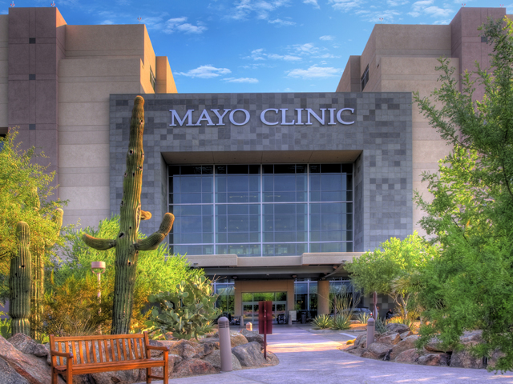

Mayo Clinic Arizona Pulmonary Pathology Fellowship

Openings: 2023-2024
The mission of the Pulmonary Pathology Fellowship at Mayo Clinic's campus in Arizona is to train pathologists to become competent in the evaluation and diagnosis of routine, complex, and esoteric pathologic specimens from the lung, pleura, and mediastinum; to become consultants to other pathologists on these cases; and to advance the science of pulmonary pathology.
The curriculum of this one-year fellowship is uniquely designed to fulfill this mission.

Accreditation
The program is accredited by the Accreditation Council for Graduate Medical Education (ACGME).

Qualifications

To be eligible for the Pulmonary Pathology Fellowship, the applicant must have a medical degree with U.S. or Canadian residency training in anatomic pathology or anatomic and clinical pathology. Preference is given to those who have completed a surgical pathology fellowship.

Clinical training
The fellow will be exposed to all areas of thoracic pathology, including neoplastic and non-neoplastic diseases of the lung, pleura, and mediastinum. This occurs through review of in-house specimens, consultation cases received in our large referral practice which averages 3,500 to 4,000 thoracic specimens a year, and review of the Charles B. Carrington Memorial Teaching Collection, one of the largest curated collections of thoracic pathology cases in the world containing over 30,000 cases. One month will be spent rotating on our busy cytopathology service, where you will see samples obtained by endobronchial ultrasound (EBUS) and help provide rapid on-site assessment of samples.

Summary of benefits/stipend information
View the benefit highlights for Mayo Clinic School of Graduate Medical Education appointees, and the resident and fellow stipend levels.

How to apply
Mayo Clinic School of Graduate Medical Education does not process printed applications to this program. You must apply through Recruit, a third-party application service. No matching program services are used.
Mayo's academic year begins in July. You must submit a completed application form and all required documentation ideally no later than Dec. 1, approximately 18 months before the program start date. Positions may be offered prior to the application deadline and may also be offered if the Dec 1 deadline is unable to be met due to extenuating circumstances.
Complete the following steps to apply online using RECRUIT:
- Create an account in “Recruit” to begin the online application for admission: https://mccms.elluciancrmrecruit.com/Apply/Account/Login
- All applications to Mayo Clinic School of Graduate Medical Education programs must include the application materials listed on the website:
https://college.mayo.edu/academics/residencies-and-fellowships/admissions-and-benefits/application-process/
Applicants considered for an appointment will be invited for a personal interview with the program director and selected faculty. All interviews are conducted virtually.

Contact Information
Dr. Henry Tazelaar, Program Director: tazelaar.henry@mayo.edu
Michele Griggs, Education Program Coordinator, 480-301-4335 griggs.michele@mayo.edu

